

DLD Lab-04
Multivariable Functions


Instructor: Engr. Waseem Ullah
EL1005 – Digital Logic Design-Lab
SEMESTER SPRING 2025
Contents
1. Objectives: 2
2. Outcomes : 2
3. Equipment Required: 2
4- Simplification of 3 variable Boolean function using Kmap 2
5. Min term(product) 3
6. Max term(SUM) 4
7. Min Term & Max term 4
8. Sum of Product (Min Term) 5
9. Product of Sum (Max term) 6
10. Lab Task 13

Objectives:
3/4 variable Boolean function simplification using K-map in SOP (sum of products) and POS (product of sums ) forms
Implementation of simplified expressions using AND, OR and NOT gates
Implementation of simplified expressions using NAND and NOR gates

Outcomes:
Students should be able to
Simplify, implement and verify 3/4 variable Boolean expressions in SOP and POS forms,
and using only NAND and only NOR gates.

Equipment Required:
- DEV-2765E Trainer Board/ Multisim 14.2 /Logic.ly
- 7404 hex NOT (Inverter) gate IC
- 7408 quad 2-input AND gate IC
- 7432 quad 2-input OR gate IC
- 7400 quad 2-input NAND gate ICs
- 7402 quad 2-input NOR gate ICs
- Multisim / Logicly

Simplification of 3 variable Boolean function using Kmap
In the lab there are 2 ACs and a door . There is a monitoring room as well . If any of the AC is on , AND the door is open ( i.e logic one for the door ) , then an output signal (i.e logic 1 ) is issued to the monitoring room , otherwise output remains zero .
Make a truth table corresponding to the above scenario, use A1 and A2 for ACs and D for door and S for output signal , simplify the Boolean function into
(a) sum-of-products form and (b) product-of-sums form

Min term(product)
Minterm is product of boolean variables either in normal form or complemented form. In Minterm, we look for the functions where the output results in “1”
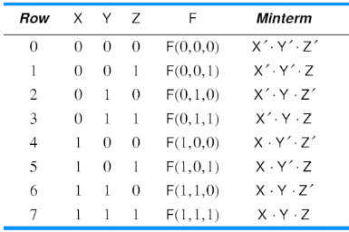

Max term(SUM)
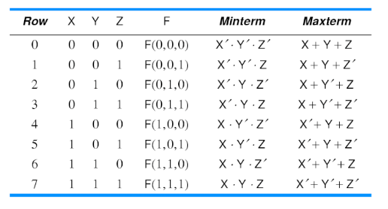

Maxterm is sum of boolean variables either in normal form or complemented form. In Maxterm we look for function where the output results in “0”

Min Term & Max term
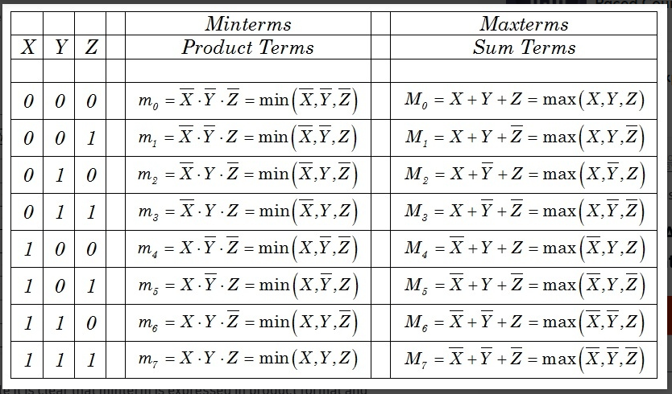

Sum of Product (Min Term)
The SOP (Sum of Product) is the methods for deducing a particular logic function. Conversely, SOP produces a logical expression comprised of the OR of the multiple AND terms
A Sum-Of-Products Boolean expression is exactly a set of Boolean terms added together, each term being a product of a combination of Boolean variables. To get the Sum of Products form from a truth table, OR together all of the min terms which has a value of 1.
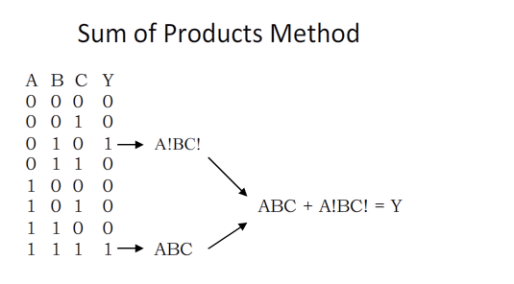
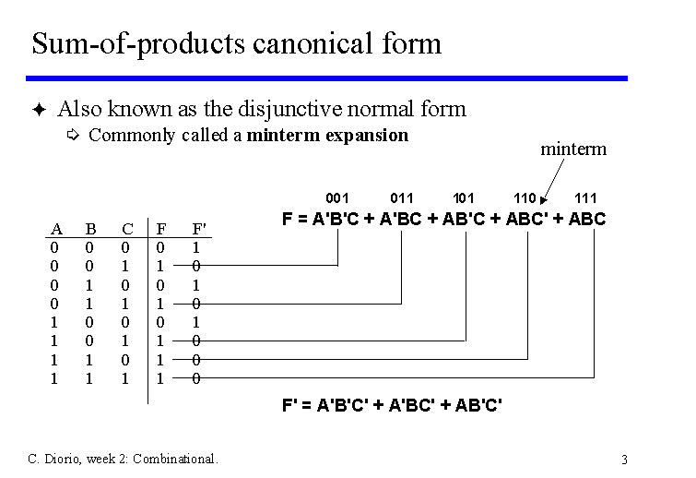

Product of Sum (Max term)
The POS (Product of Sum) is the methods for deducing a particular logic function. Conversely, POS produces a logical expression comprised of the AND of the multiple OR terms
A Product of Sum Boolean expression is exactly a set of Boolean terms product together, each term being a added of a combination of Boolean variables. To get the Product of Sum form from a truth table, product together all of the max terms which has a value of 0.
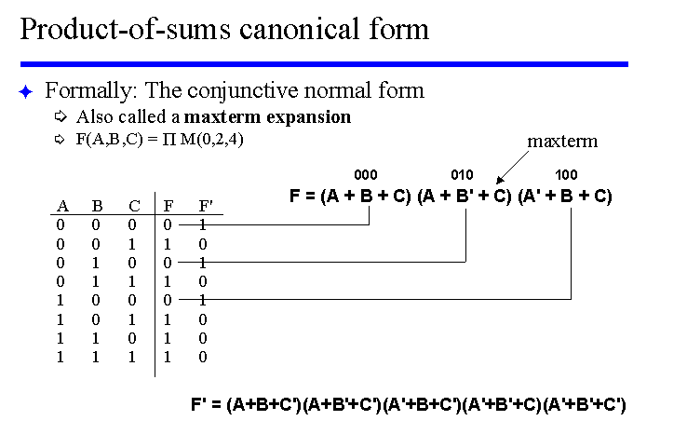

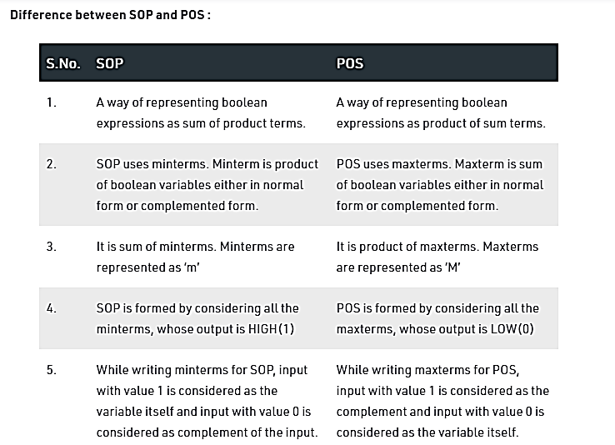

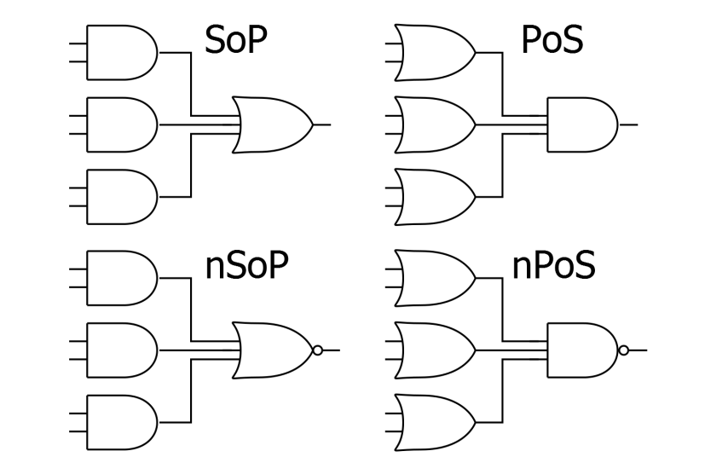

Lab Task

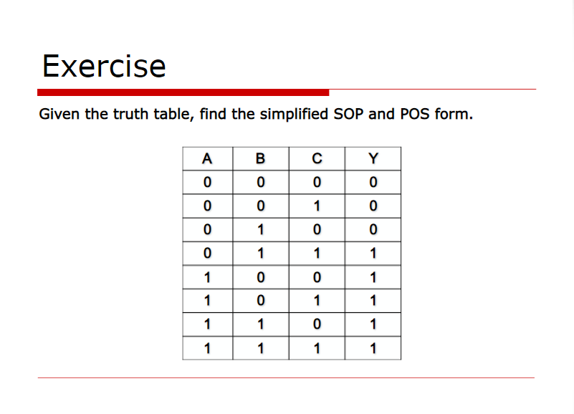
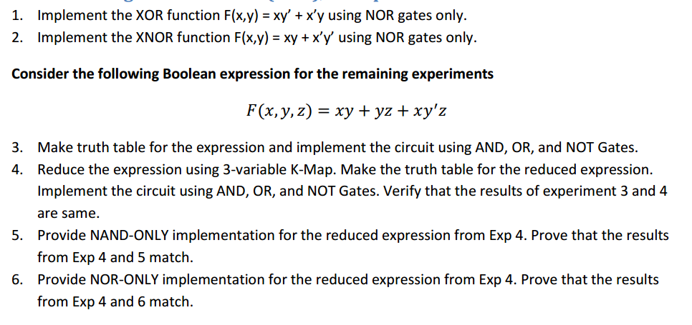

- Implement the following functions on Multisim as well as on hardware
- F= A’B’C+AB’C’+ABC
- F=ABCD + A’B’CD+ A’B’C’D



